So I was able to access the data in vscode upto a max of 5 million ( wouldn’t load above it ) which took a minute to load and did couple of observations:
- Typical sports name occurrences: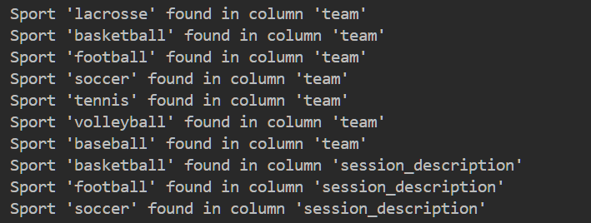

- Frequency of sport appearing in Column-team:
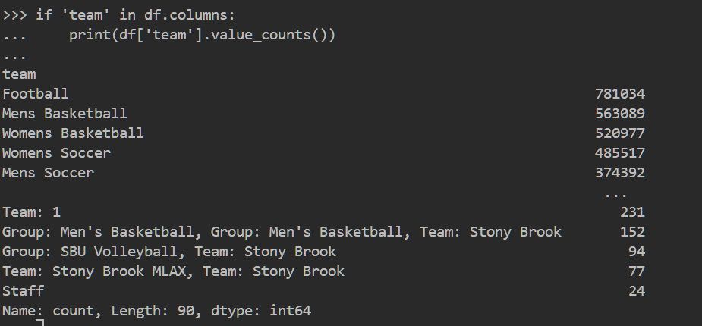

- Top 5 metrics used across the 5 teams of interest:
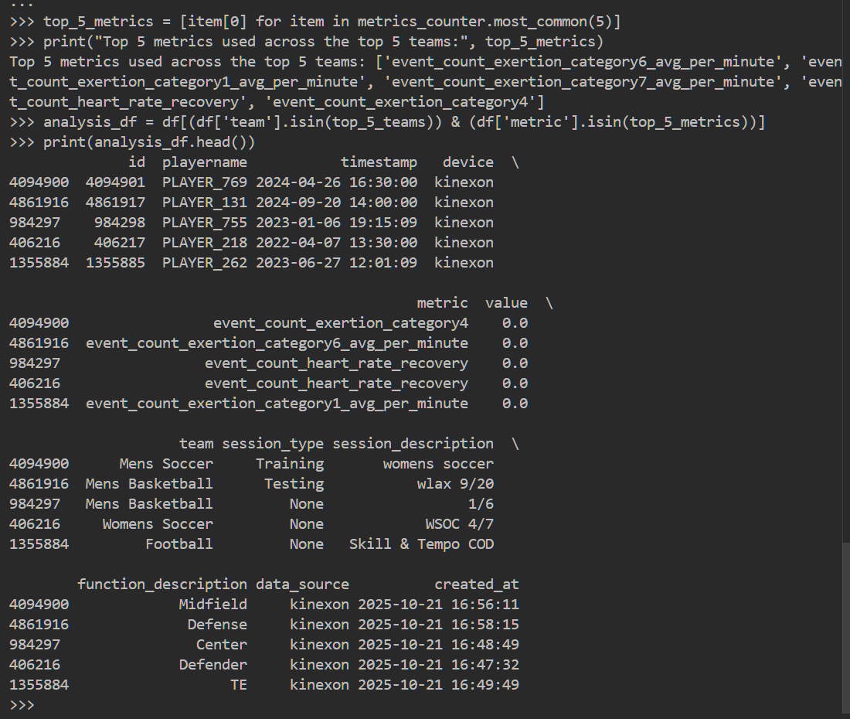
Here’s the catch: in the 5 million dataset I see more event_count_exertion_category metrics.
Paul’s data : 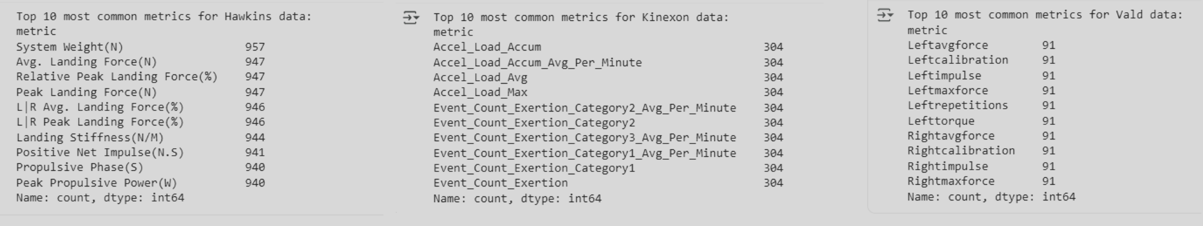
Landing Force in various forms are used.
- Top 5 widely recognized metrics (with more sample size for statistical power) across the selected teams which can be used for Systematic Review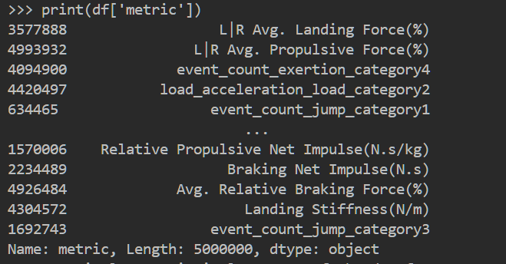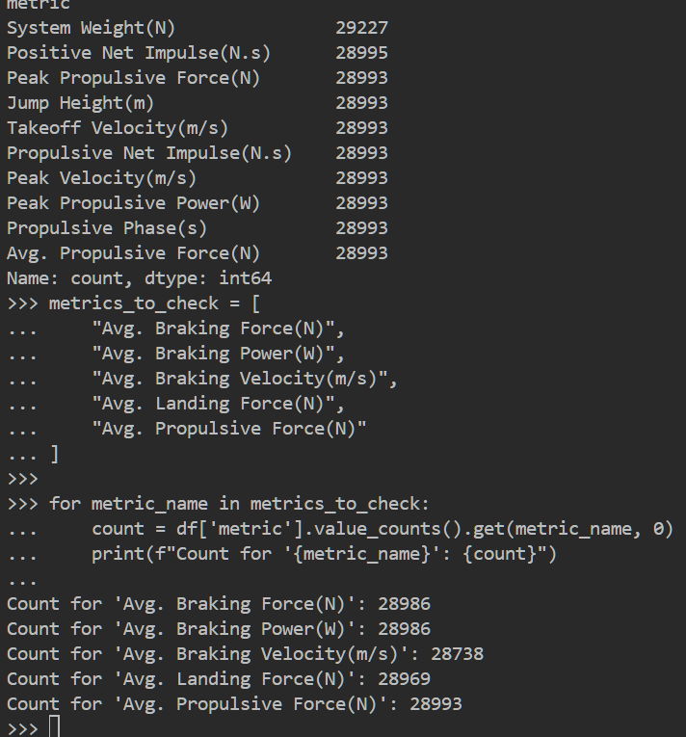
- So comparing with Paul’s data and availability of research , if all are ok, we can choose these but please research as well !! 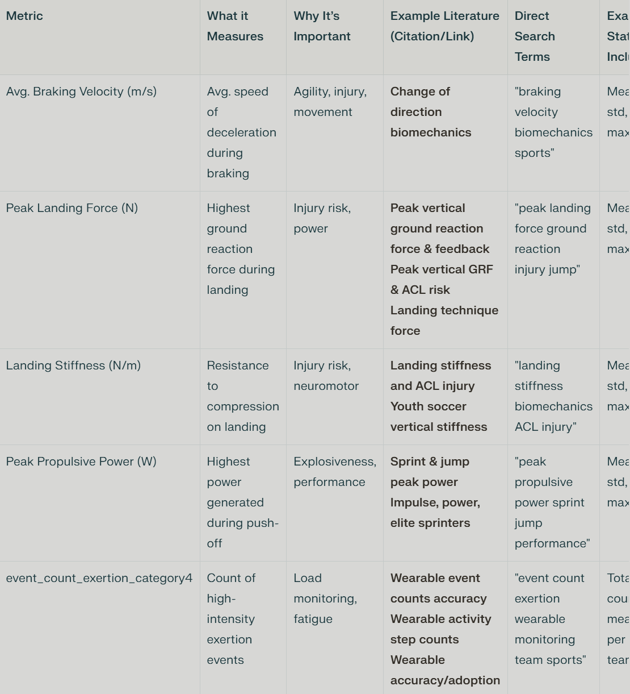

- Why these again?
- These metrics are highly published in sports science literature, especially in collegiate teams and performance, injury, or training research. Landing Force, Stiffness, and Impulse/Power are universally reported in jump, sprint, agility, and collision studies (including football, basketball, soccer, etc.).

- Avg. Braking Velocity (m/s): Measures speed at which braking occurs, valuable in performance/injury studies.

- Peak Landing Force (N): Key for high-impact moments and injury risk.

- Landing Stiffness (N/m): Connects to explosiveness and safe landing.

- Peak Propulsive Power (W): Assesses maximum power during propulsion. Directly relates to explosive athletic movements, widely used in sprint/jump/agility research.

- event_count_exertion_category4: Quantifies exertion/load, important for athlete monitoring. Found in Kinexon data, useful for load monitoring, quantifies total exertion events (well represented in team sports).

- Why not ? - Accel_Load_Avg, Left/Right Max/Avg Force (because the Kinexon/Valid devices seem more limb- or segment-specific).

DEFINTION OF TERMS SO WE CAN UNDERSTAND WHAT WE ARE LOOKING AT!
- Use braking velocity (m/s) for movement speed/control studies.
- Cite or analyze each separately for clarity in your review or analysis.

Landing Stiffness (N/m)
- Definition: Measures the resistance of the body to compression upon landing–it’s the ratio of the change in landing force (N) to the change in displacement (m) during ground contact.
- What it reflects: How “stiff” or “soft” an athlete lands; higher stiffness means less joint flex, lower stiffness means more flex and “soft” landing.
- Typical use: Injury risk (ACL, impact injuries), assessment of neuromuscular control, jump-landing technique.
- Key point: It’s related to how force is absorbed and distributed by the body’s joints during impact.

Peak Propulsive Power (W)
- Definition: The highest power output (in Watts) generated by an athlete during the propulsive phase (push-off) of a movement, such as a sprint, jump, or acceleration.
- What it reflects: The explosiveness and anaerobic power of the athlete.
- Typical use: Assessing athletic performance, especially sprint/jump ability; power-oriented training effects.
- Key point: Peak power is about generating movement, not absorbing force.
In summary:
- Landing stiffness: How well you absorb forces when you land.
- Peak propulsive power: How powerfully you push off to accelerate or jump.
They measure opposite aspects: stiffness for shock absorption, power for force production. Use both for a complete picture, but do not treat them as the same!
- Event Count Exertion:
The number of times an athlete exceeds a predefined exertion threshold—often high-intensity runs, sprints, changes of pace, accelerations, or forceful movements.

Why is it Important?
- Measures physical workload and intensity
- Monitors how much “high effort” activity an athlete does
- Helps coaches, trainers, and sports scientists track training load, fatigue, and risk of overtraining/injury
- Allows comparison of player effort across practice and games

How is it calculated?
- Wearable sensors/devices (e.g., Kinexon) monitor player movement, force, velocity, and acceleration.
- When a pre-set threshold (e.g., acceleration > 3 m/s² or speed > certain value) is reached, an “exertion event” is counted.
- These are summed for each athlete or session, resulting in the event count.

Typical Use Cases
- Soccer, football, basketball: Tracking number of sprints, “high-effort” runs, or explosive efforts per player.
- Return-to-play: Comparing “exertion event” count pre- and post-injury.
- Periodization/training: Monitoring changes in exertion count over weeks or cycles.

In summary:
- It’s not a measurement of force, velocity, or power itself,
- It is a count of how often an athlete performs a defined “high-effort” or “exertion” action, used for workload and effort tracking.

Reference example:
See studies using Kinexon/Catapult/wearable data:
- Wearable event counts in sports monitoring
- Wearable activity/step count accuracy
It is a practical, modern, and highly useful metric for team sports science.

